HOW TO COMPLETE THE 990-N IRS E-POSTCARD EVERY YEAR BY FEBURARY 15th
For all Optimists Club with less then $50,000.00 in treasury account

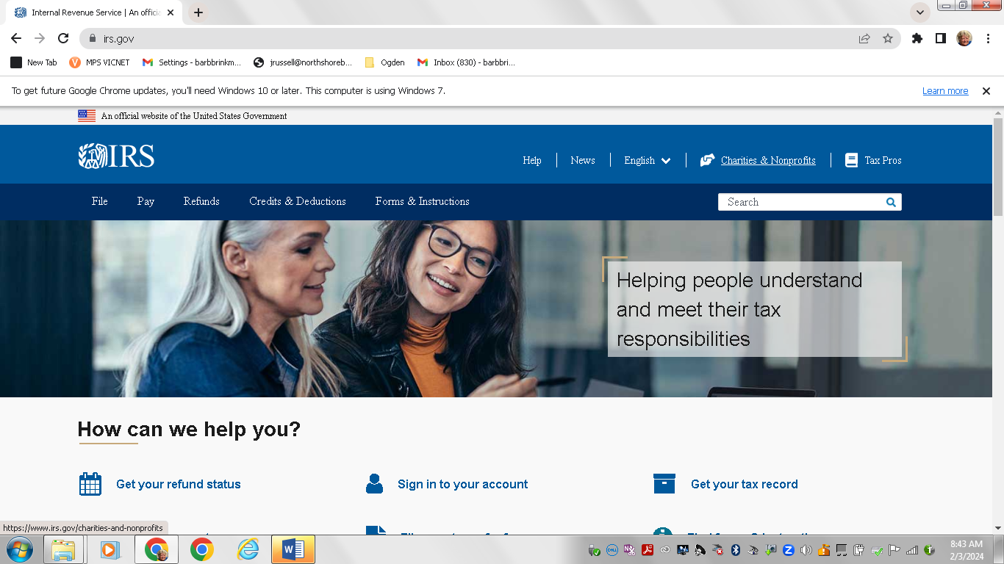
1. SIGN ON TO IRS.GOV
2. CLICK ON CHARITIES & NONPROFITS LINK TOP RIGHT OF SCREEN.
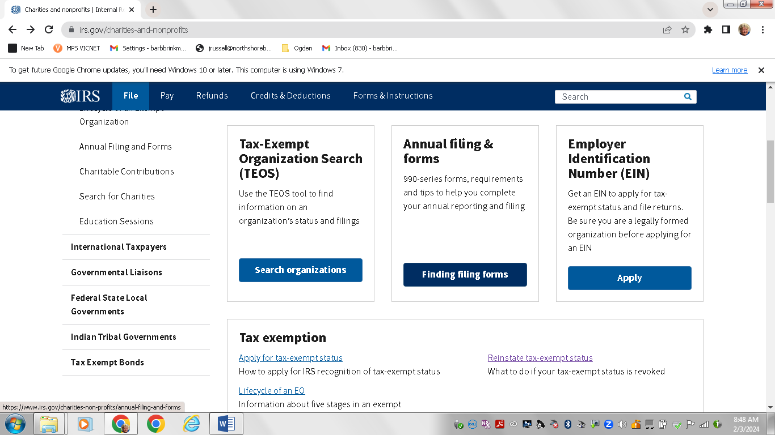
3. SCROLL DOWN THE SCREEN AND CLICK FINDING FILING FORMS ON BLUE BOX IN THE MIDDLE OF THREE BOXES.
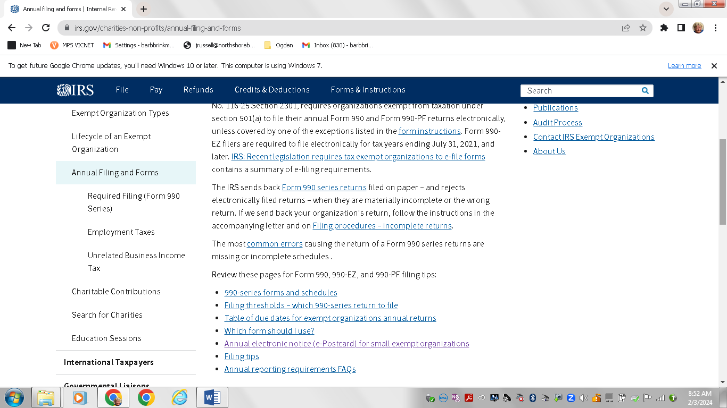
4. SCROLL DOWN AND CLICK ON ANNUAL ELECTRONIC NOTIC IE-POSTCARD FOR SMALL EXEMPT ORGAZITIONS.
5. ON THIS SCREEN, SCROLL WAY TO THE BOTTOM AND CLICK ON THE BLUE BUTTON THAT SAYS “SUBMIT FORM 990-N (e-postcard). SHOWEN ON NEXT PAGE.
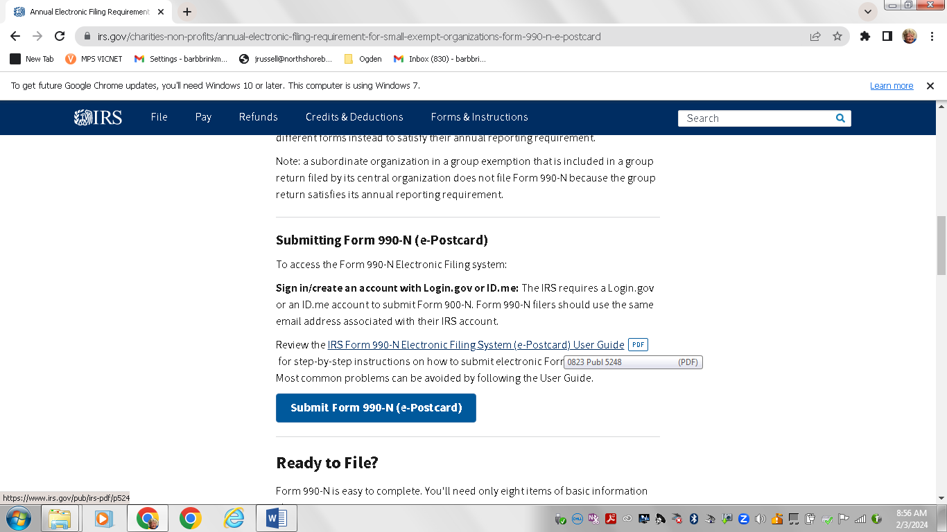

YOU WILL THEN SEE THE SIGN ON SCREEN. SEE NEXT PAGE.
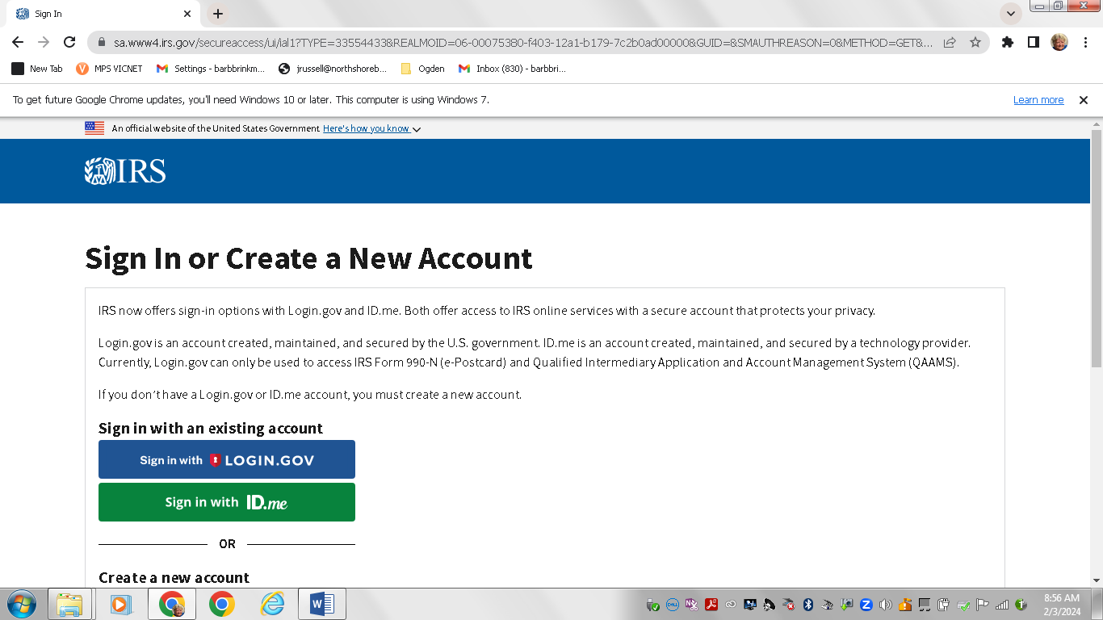
6. CLICK ON Sign in with LOGIN.GOV
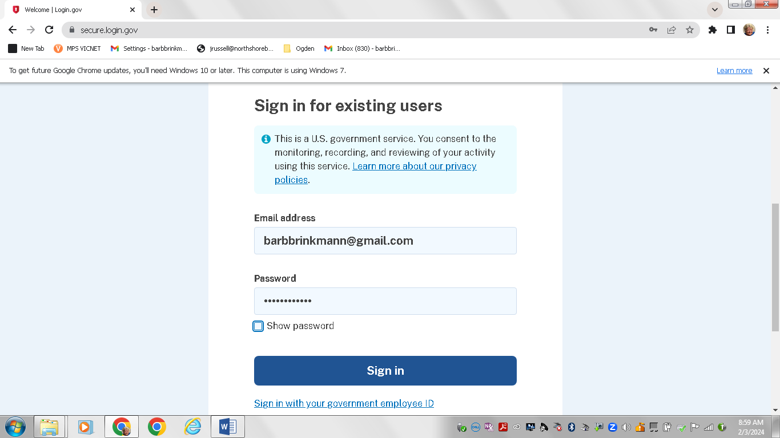
7. SCROLL DOWN TO ENTER YOUR EMAIL ADDRESS AND PASSWORD.
IF YOU DON’T HAVE A PASSWORD CLICK THE “CREATE AN ACCOUNT” AND FOLLOW THE DIRRECTIONS.
8. ON THE NEXT SCREEN YOU SHOULD RECEIVE A TEXT ON YOUR PHONE. ENTER THE NUMBER FROM THE TEXT AND CLICK
9. CLICK ON THE MANAGE E-POSTCARD PROFILE BUTTON ON THE LEFT.

e-Postcard Profile
- Home
- Security Profile
- Logout
e-Postcard Profile
Select EIN
Organization Details
Contact Information
Confirmation

You are logged in as: Exempt Organization Edit user type

EIN- ADD EIN

10. ON THIS SCREEN YOU MUST CLICK THE EDIT LINK TO THE RIGHT OF “Exempt Organization”.

