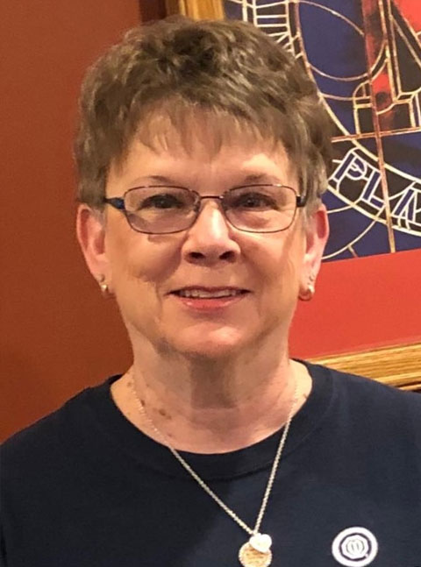Greetings SWIS District Optimist Friends  
  
This takes me back in time, the date October 1, 2020, and I was sitting writing my Governor Message the first time!  A moment in time, a place in history, an accomplishment never expected, a creation of everlasting memories.  Now, here we are, creating another moment in time some four years later.  
  
I am beyond grateful to serve this Optimist year with two very good Optimist Friends who have proven time and again their passion for Optimism along with serving youth and communities, Jo’El Pearlman and Maureen Crombie.  As our 24-25 Governor Team and as our theme states, we are “Better Together”.  
  
I find it hard to put into words my feelings of being able to once again serve our SWIS District in the capacity of CO-Governor.  It is a pleasure to serve our clubs, our members and above all else, serve our youth.  Isn’t that what we are all about???  
  
My daily focus is doing what I can, as myself, a member of the Platteville Optimist Club and now Governor of the SWIS District, to make our world a better place for our younger generation to grow up, have a meaningful life and live in a world of peace and freedom.  How and what do I do, I live by the Optimist Creed.  I recently asked a group of Optimist Club members if they say the Creed other than when at a meeting.  Of course, the response was no.  That made me think, neither do I say it other than at a meeting.  I handed out a bookmark with the Creed and/or something to put on your refrigerator or bathroom mirror, and encouraged these members to say the Creed daily.  Change comes in numbers and together we can make that change happen.   
  
My term as CO-1st Qtr SWIS Governor is going to be short lived, 3 months (first quarter).  However, I will be an active CO-Governor, reaching out to touch base with club leaders.  I’m not a traveler in the Wisconsin winter; however, I’m very experienced in using a cell phone.  I want to be your “sounding board”.  I want to hear your concerns, your achievements, your suggestions, your whatever you want to share.  
  
Before closing, I want to share the goals set by OI President Jan Oord Graves, who has not only requested individual clubs join her in reaching these goals but likewise needs our support:  
  
     - By September 20, 1925 OI membership will be at plus 5% by way of retention of current members through member engagement and growth through support of our regional growth committee.  
  
     - Marketing – think of Optimist International Clubs when you hear the word Optimists.  We can accomplish this and support OI with a 5% increase in opened external social media post.   
  
     - To encourage clubs to stay current on club roster updates, OI will refine member publications, leading to a 5% increase in member communications.  
  
     - OI is committed to maintaining positive financial stability through dues being paid on time in addition to researching other resources and strategies to support our organization.  
  
As Optimist Clubs with responsible individuals leading our clubs I have no doubt but what we will support President Jan is accomplishing her goals.  
  
In closing, thank you for Being an Optimist!  There is no greater compliment I can pay each of you than by referring to you as an Optimist.  We are looking forward to a year of challenges that we will turn into opportunities.  We will have informative, interactive quarterly conferences, provide training to help leaders achieve their goals and last, but not least, have fun.  We will live up to our 24-25 theme “Better Together”.  
  
Forever an Optimist  
Maxine Lane, CO-1st Qtr SWIS Governor  
First Quarter 24-25